The Market Is Fractal — So Is Structure
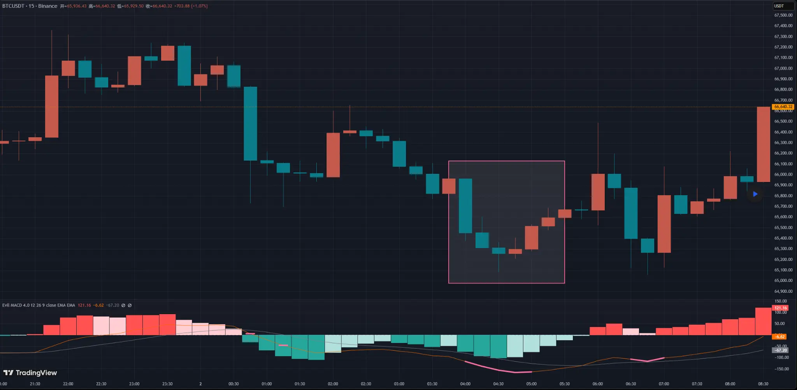
BTCUSDT 15-Binance Chart
Why is it that sometimes you clearly see a reversal coming, yet you can never find a proper entry?
Because the confirmation structure is not on this timeframe. It is hidden within a smaller one.
Today I want to talk about an important concept: **self-similar structures**.
This may be difficult. It touches on philosophical and even metaphysical ideas. But if you can understand it — or perhaps understand it one day in the future — your trading will undergo a qualitative shift.
The idea comes from mathematics. Many of you have probably seen videos explaining fractal geometry.
Why bring this up?
Because in live trading, we often cannot find a clean entry point — yet the reversal objectively exists. The entry can sometimes be identified by examining different timeframes, provided that the structures across those timeframes are self-similar.
It is somewhat similar to the nested-structure concept in Chan theory.
Let’s look at an example.
Suppose we are on the 15-minute chart. A bottom warning signal appears, and price is indeed forming a bottom structure. However, the price action is complex and no valid trendline can be drawn.
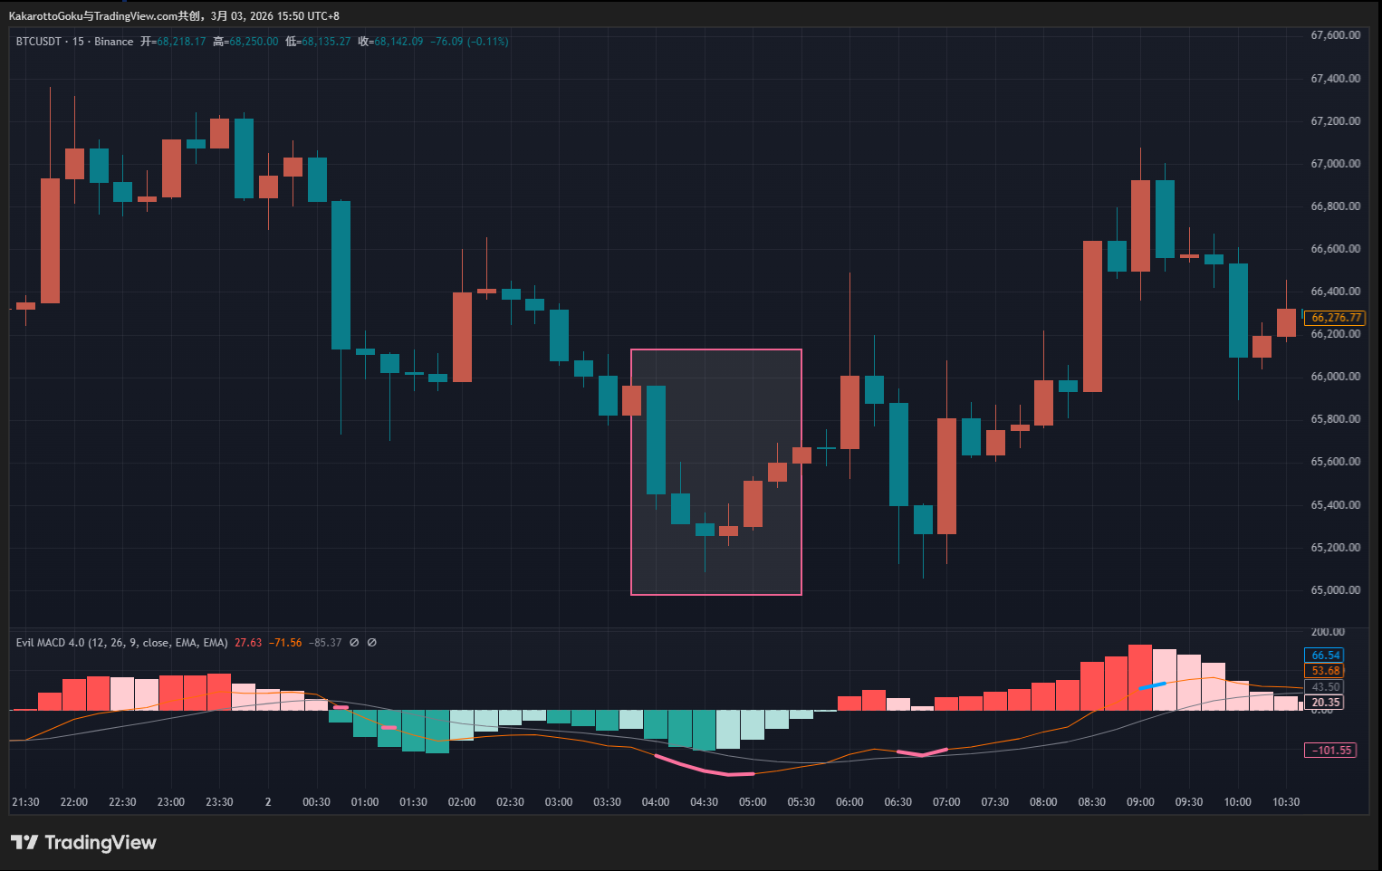
BTCUSDT 15-Binance Chart
On the 15-minute chart, we only see a dense consolidation box. There is no trendline here — because you need three aligned points to draw one, and those points simply do not exist on this timeframe.
So where is the entry?
In Chan theory, if we observe a central structure with more than nine strokes, we recognize that it likely belongs to a higher-level structure rather than the current one. This reflects a fundamental truth: the market is unknown and chaotic. Analytical frameworks such as Chan theory exist not primarily to find buy and sell points, but to classify price behavior.
The core is not prediction. It is classification.
We use standardized structural definitions to impose order on an otherwise chaotic market. Importantly, we are not forcing the market to adapt to our system. We adapt to the market. We observe its structure and follow its logic.
This philosophy must come first. When I determine entries or place stop-losses, this way of thinking is always present.
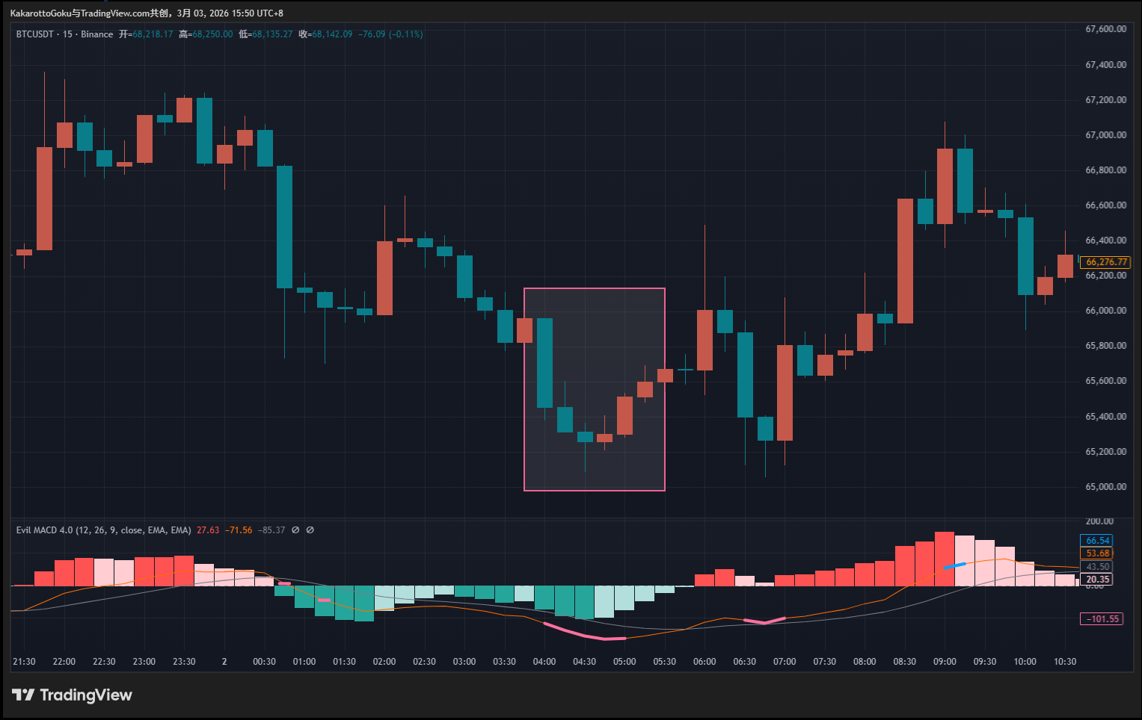
BTCUSDT 15-Binance Chart
Now back to the example. On the 15-minute chart, we cannot draw a trendline. Without a trendline, we lack structural confirmation for entry. So we switch to the 5-minute chart and observe whether a self-similar structure exists.
If we were using Chan theory, we would look for divergence segments. In our case, we continue looking for bottom warning signals and trendlines. The thinking remains the same — only the tools and rules differ.
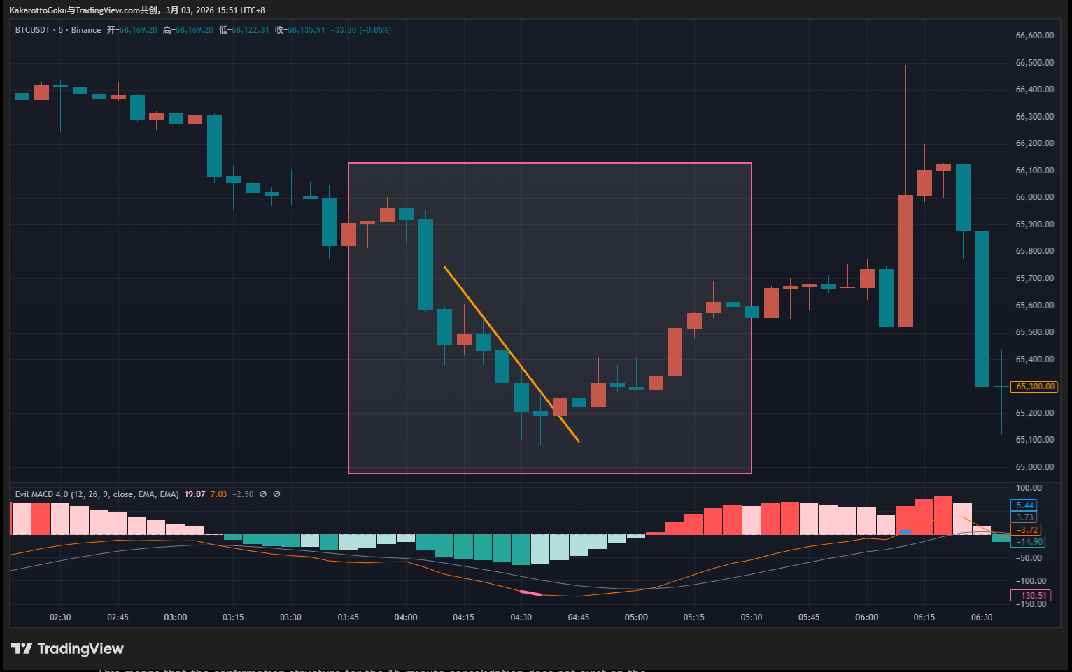
BTCUSDT 5-Binance Chart
On the 5-minute chart, we may clearly see:
- A bottom warning structure
- A valid trendline
- A trendline breakout level
This means that the confirmation structure for the 15-minute consolidation does not exist on the 15-minute chart itself — it is embedded within the 5-minute structure, or even smaller.
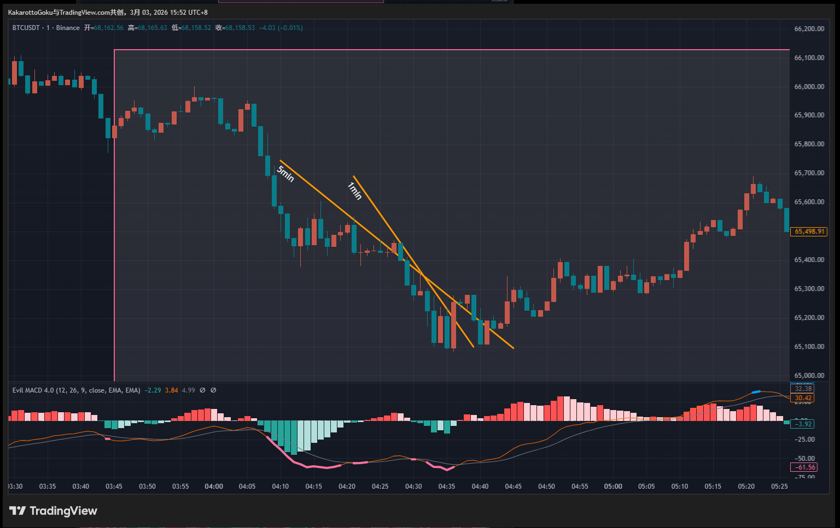
BTCUSDT 1-Binance Chart
(Here we are only discussing self-similarity of structure, not the quality or precision of the entry. Whether the breakout is high-quality is a separate discussion. The focus here is understanding the philosophy of adapting to the market.)
Now the question arises: Are there extreme cases where we search across multiple timeframes and still cannot find a valid structural entry?
Yes. And they are not rare.
Especially in highly volatile markets like BTC, where conditions can shift from calm to chaos within seconds. Even on the 1-minute chart, you may find no recognizable structure — only a sudden explosive move.
In such cases, the correct decision is simple: **Do not trade.**
Our system is built to adapt to structural patterns. When the market temporarily behaves in a way that cannot be classified under our framework, we step aside. From a Chan-theory perspective, such behavior may belong to a much larger timeframe structure that is not yet visible.
The good news is that these explosive moves usually appear first on the 1-minute chart. It becomes relatively easy to distinguish between structured movement and sudden expansion.
When a sudden move occurs, stay away from that zone. Wait for structure to re-emerge. Then resume applying your rules.
This is a higher-level way of thinking. It is trading philosophy. At its core, it is about understanding and respecting the market. We adapt to it. With limited knowledge, we attempt to classify infinite price movement. We only participate in the portions we can understand.
Many traders make the opposite mistake. They try to capture every move. When sudden volatility appears, they desperately search for patterns within randomness. They abandon the 2% of structural certainty to chase the 20% of randomness.
But trading profits are like reflections in water. You cannot chase them. You cannot grasp them.
Today’s discussion may feel abstract. Whether it resonates depends on your current level of understanding.
> The Bodhi tree was ne'er a tree to sight,
> No pedestal supports the mirror’s face;
> If void be all within the dawning light,
> Whence comes the dust to mar this hallowed space?

